Made to Measure Tracks Order Form –
Part 2 of 2
Bay Window Dimensions
These diagrams are for representation purposes. We understand that these diagrams may not be a true representation of the actual shape of your bay

Wall Dim
Track Dim

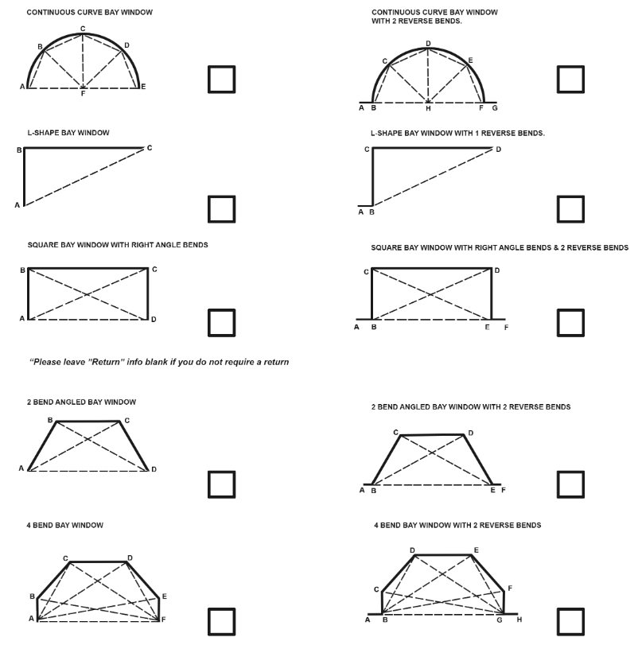

A - B |  | A - F |  | H - C |  | G - H
B - C |  | F - E |  | H - E |  | B - G
C - D |  | F - C |  | A - C |  | B - E
D - E |  | D - F |  | A - D |  | C - G
E - F |  | B - H |  | C - E |  | D - G
F - G |  | H - F |  | A - E |  | E - G
B - F |  | H - D |  | C - F |  | B - D

WALL MEASUREMENTS AND TRACK SIZE
Please supply as many measurements as you possibly can, if you can add the angles then please do. The more measurements/dimensions we get the more accurate we can be when bending the product for you, enabling us to get this right the first time.

